On your server VM, create a new folder called shared on the desktop.

Right click the desktop, cursor over New and click folder.

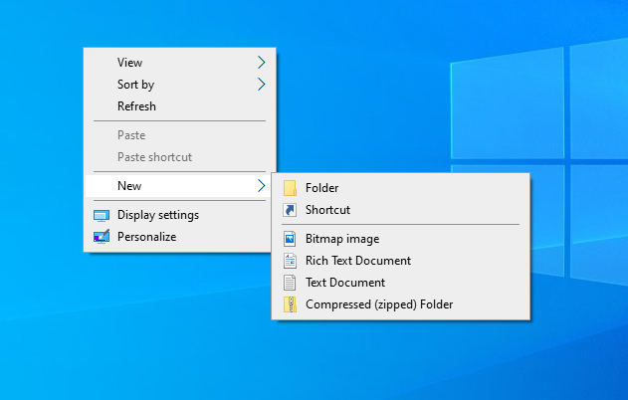

Once the folder is on the desktop, right click it and click properties.

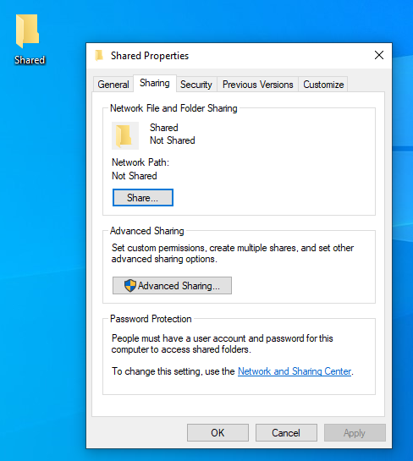

Click the advanced sharing button. In the new window, make sure “Share this folder” is checked. Click the permissions button.

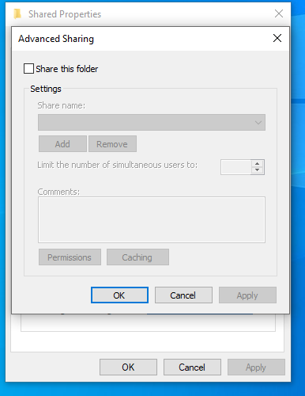

In the permissions window, make sure that “Everyone” appears under the group or usernames panel. Check the box that gives “Read” permissions.

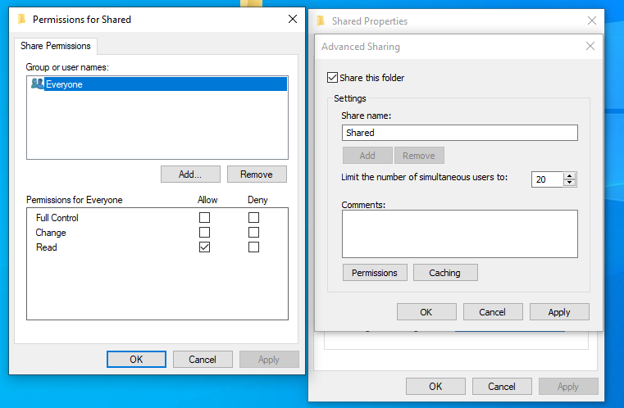

Click apply and ok to close all the windows.

Return to the desktop, and navigate to the shared folder you have created. Inside the folder, create a new file. Right click > new > Text Document.

Call this document “Test”.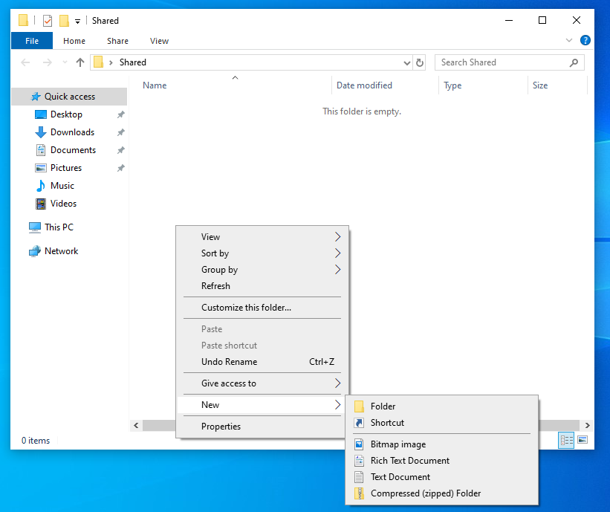

If you correctly configured your network in the first lab, and correctly configured your shared folder, you should now be able to access it from the client PC in the network pane.

If it does not show, return to the lab session 1 document to begin troubleshooting your network.

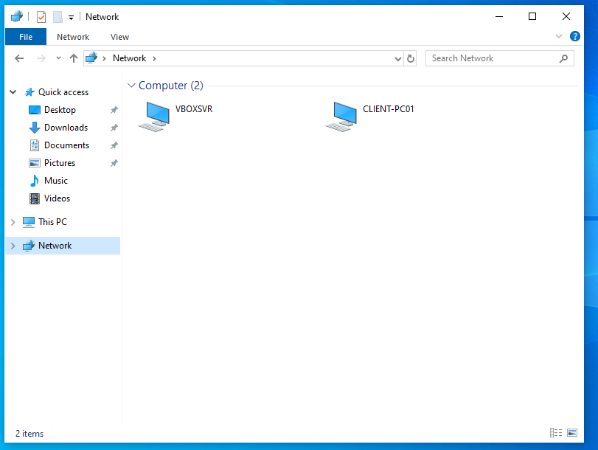

Note that CLIENT-PC01 will show as whatever your server is named.

If you click on the server computer in the network window, you should be able to access the folder and file you created.

Try to modify the file. What happens?

Return to the permissions window for the shared folder and check the box that says full control, then apply.

Access the shared folder from the client machine again and try to modify the file. What happens?

Who can access the shared folder and its contents?

How would we change who is able to access the folder?